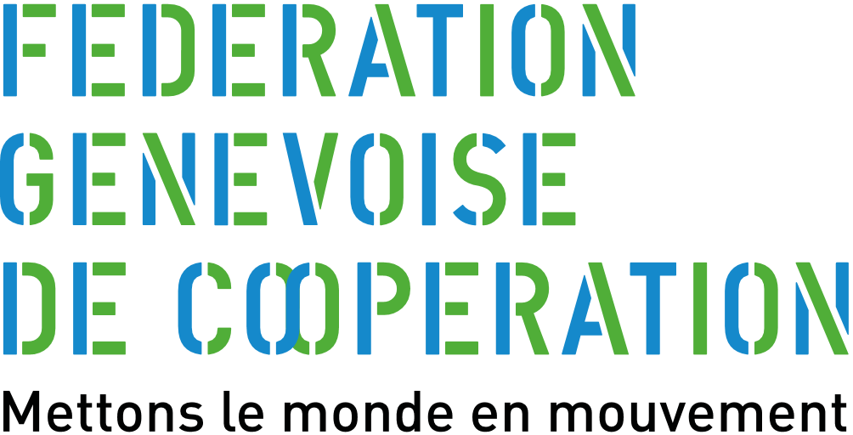
(Insert the logo of the association above)

DEVELOPMENT PROJECT APPLICATION FORM
Important Note: Before completing this application form, it is advised to first fill in the logical framework, the partnership assessment form as well as the risks analysis form. These three documents must be attached as annexes to this application form.
Please do not modify any titles or subtitles; leave all the sections in their current order and do not change their formatting.
However, you can delete the explanation notes in italics, after having read and taken them into consideration.
(Your completed document should not exceed 12 pages for the new projects and 14 pages for the application for extensions).

Project Name:
(Use a clear and interesting title)

New Project: □ Yes / □ No
(Is the project to be funded by FGC for the first time?)

If this is an extension of an existing project, please quote the FGC Reference Number:

Identify the location of the proposed project’s main activities:
(e.g. Country, region, town etc.)

Identify the key areas of the intervention (using key words):
(Please use 2-5 key words, with a maximum of 30 characters for each key word.)

1. RESPONSIBLE ORGANISATIONS
1.1. Name of the FGC member organisation (MO) presenting the project:
(Include address, phone no. & email)

1.2. Name of the contact persons:
(Include address, phone no. & email (please provide details for two contacts))
1)

2)

1.3. Local Partner/ coordination/ main network responsible for project implementation (first complete the partnership assessment form that can be downloaded on the FGC website and which should be annexed to this form):

2. Finances
2.1. Project costs for the period from Insert date to Insert date
a) Sub-total cost of the project’s field activities, excluding contingency costs (or, for volunteer exchange projects, enter value from ‘Sub-total of FGC eligible costs excluding contingency costs’) (= A in the FGC budget form)
CHF Insert amount
b) Total cost of the project (including indirect project costs) (= L in the FGC budget form) :
CHF Insert amount
c) Total budget requested from the FGC (including indirect project costs) (=M in the FGC budget form):
As in the budget annexed, total budget requested for the period from Insert date to Insert date (i.e Insert amount years)
CHF Insert amount
d) Is it expected to be an extension phase to the project: □ yes / □ no
Yes: no. of years: Insert amount Cost estimate (in CHF) Insert amount
e) Indicate the rate of exchange applied to the budget estimate:
(The rate of exchange is that which was used in the budget, that the MO considers appropriate and which can be justified if necessary)
1 CHF = xxxx.x + name of local currency
2.2. Funding provided by the member organisation, the local partner and/or other donors for this project:
NAME or ORGANISATION | AMOUNT IN CHF | PERIOD COVERED | STATE OF AGREEMENT  (Put a cross in the corresponding space)
 |  |  | Agreed | Under negotiation
1. Member Organisation
2. Local Partner
3. Other donors
4.
5.
(The data in this table relates to the funds that the MO, partner(s) and/or other donors will be contributing in addition to that requested from FGC. The sum of the amount requested in section 2.1 c) and the amount stated here will therefore be equal to the total project budget stated in section 2.1 b.)
2.3. If this funding request is to provide additional support to a project currently underway, please provide details of previous and/or current funding arrangements:
(If relevant, provide details on funding support (i.e. from the FGC, the MO, local partner(s), or other donors) for any previous/ongoing phase.)
NAME or ORGANISATION | TOTAL AMOUNT  (in CHF) | PERIOD COVERED
FGC – ref.:
MO:

3. PROJECT IDENTIFICATION
3.1. Context analysis in relation to the project:
a) Describe the geographic, political social and economic context in relation to the project’s activities:

b) Identify any gender or particularly vulnerable populations issues in relation to the project’s activities:

3.2. Project’s identification process and justification (background, initial idea, etc.)
a) Identify what led to the project’s development:

b) Where this is a continuation of an existing project, provide the original objectives and the results achieved, the changes that have been noticed since the first phase of the project and the reasons why the project should continue:
(This information must be provided even if previous phases were not funded by FGC.)

c) Identification and management of potential conflict of interest (incl. any family link) that could exist between the stakeholders directly involved with the project (partners, beneficiaries, suppliers, etc.):
(Note that links are note prohibited but should be clearly and transparently specified and the MO should indicate the measures established to ensure that no conflicts will happen in relation with these links of interest.)

3.3. Integration of the project into the national policy framework. Describe how the project fits into national (and/or sub-national) policy frameworks, action plans, etc. and present the institutions (NGOs, governments, ministries, etc.) with which relationships could be developed:
(If relationships exist, provide an organisational chart, as an annex, clarifying the relationships/networks of the principal stakeholders active in the sector(s). Identify actual/potential partnerships with other organisations active in the field, key institutions etc.).

4. MAIN OBJECTIVES AND PROJECT STRATEGIES
(Complete the logical framework in Annex 1.Please limit this document to 2 pages – 4 pages max.)
4.1. General objective, over the medium/long-term:
(1 objective maximum - Describe the wider development goal to which this project will contribute.)

4.2. Specific objectives, in the short-term:
(Ideally 2 objectives max.)

4.3. Strategy to achieve the project objectives:
(Methods used in the field)
a) Method /Approaches:
(Methods and/or approaches employed by the partner to conduct the project activities and their justification in relation to the local context.)

b) Long-term planning:
(If a subsequent phase of activities is anticipated after the completion of this particular project, please present your anticipated milestones and the final objective.)

4.4. Principal activities and expected outputs (timeline or calendar of events to be attached as an annex):
(Describe, in detail, the main activities and how they relate to the expected outputs. The outputs must be the same as those presented in the logical framework. In an annex, present a timeline of the main activities, again ensuring to match the contents of the logical framework.)

4.5. If this project is an extension phase, present the new project areas or aspects developed:
(In term of objectives, activities, beneficiaries, topics, geography, etc.)

4.6. Where investments are anticipated, what are the measures established with the partner/the beneficiaries regarding the use of these investments after the project?

5. PROJECT BENEFICIARIES
5.1. Direct and indirect beneficiaries of the project
(Description of the project beneficiary groups and their situation in the community/society. Distinguish between direct and indirect beneficiaries. Provide an estimate of the number of beneficiaries - Please look at the beneficiary explanation document on our website.)

5.2. Expected impacts across social groups (young people, men, women, sedentary/pastoralist/nomadic, urban/rural etc.):
(Identification of the groups which could be affected by the project, directly or indirectly, in positive or negative way).

6. GENDER APPROACH
6.1. Gender approach in the context of the project:
(Describe how you have included consideration of gender issues, and their indicators, in the development and subsequent M&E of the project.)

7. Exit strategy
7.1. Describe measures taken by the partner, including provision of finance, to enable long-term project resilience and sustainability: identify your sources of information and provide timelines:
(The potential resilience and sustainability of the project/development initiative includes not only the financial aspect, but also capacity-building within the partner organisation and of beneficiaries more generally.)

7.2. Estimation of the ripple or knock-on effects and the replicability of the project:
(Describe how the project may promote longer-term benefits and capacity-building for both the primary beneficiaries and for potential beneficiaries outside the direct influence on the project).

8. ALLOCATED RESOURCES: IN-KIND SUPPORT CONTRIBUTIONS
8.1. From the MO/Swiss partner:
(Description of the resources allocated to the project by the MA/Swiss partner.)

8.2. From the local partner:
(Participation in project development and implementation. Described the human resources, competencies and/or material resources.)

8.3. From the direct beneficiaries:
(Participation in project development and implementation. Described the human resources, competencies and/or material resources, including financial contribution not included in the budget.)

8.4. If applicable, by other actors:
(Participation, human / material resources (e.g. An embassy offering ICT equipment.))

9. MONITORING, EVALUATION & KNOWLEDGE CAPITALIZATION BY THE MO
9.1. Provide information on the various elements of the M&E system & the plans for dissemination of lessons-learned:
(Monitoring system selected, expected frequency of field visits. Will M&E be conducted by the MA itself and/or by its partners? Will there be independent, external M&E? What is the financial allocation for M&E?

10. FINANCIAL CONTROL/AUDIT OF THE PROJECT AND ITS PARTNERS
10.1. Financial control of the project / partner in the country of implementation:
(Please refer to the FGC guidelines for the financial control of projects and partners.)

11. OTHER INFORMATION

Signature of applicant:

Date: Insert date Signature:

CHECKLIST OF documents for SUBMISSION OF AN application
For submission of the first draft of the project to FGC, the following documents must be sent in French to the Secretary of FGC, in electronic form (Word or Excel for the main documents), to enable the Secretariat to make any comments directly on the documents. After the revision of the documents by the Secretariat and when the final version is ready, one single document compiling all the documents listed below (documents 1 to 14) will be sent in PDF to the Secretariat of FGC). The project budget must also be submitted in Excel and the project summary in Word. The other documents (15 to 19) can be separated PDF documents.
In addition, hard copies must be sent to the Secretariat of FGC for distribution to the members of the Technical Commission. The FGC Secretariat will inform you about the number of hard copies that are required. Please note that the documents 15 to 19 from the list below will also need to be printed, the number of copies will be confirmed by the Secretariat.
Please check-off the items of the list and add precision if necessary.
Main project documents
□ 1. The completed summary of the project in WORD format (Please use the form downloaded from the FGC website – NB: Please respect the character limit).
□ 2. Two photographs (in JPEG format) to be sent electronically to FGC.
□ 3. The completed Application Form (Please use the form downloaded from the FGC).
□ 4. In case of project extension, the application appendix presented at the end of the Application Form).
□ 5. The completed Logical Framework (Please use the form downloaded from the FGC website).
□ 6. The completed partnership analysis (Please use the form downloaded from the FGC website).
□ 7. The completed risk analysis table (Please use the form downloaded from the FGC website).
□ 8. The partner’s organisational chart.
□ 9. If applicable, an organisational chart of the sector network in the project country.
□ 10. The summary project budget (please use the form downloaded from the FGC website – max 2 pages).
□ 11. The detailed project budget (NB: This is compulsory, unless otherwise agreed with the Secretariat).
□ 12. In case of project extension, an as up to date as possible expenses table of the previous project in regard with the planned budget.
□ 13. A detailed timeline for the project’s activities.
□ 14. A list of acronyms and abbreviations, if applicable.

Additional documents
□ 15. Legal status of partner, relevant contracts and other official documents related to the project.
□ 16. Partner’s bank account details (if it is a new partner).
□ 17. For the new partners, their previous activities report if a first phase has already been implemented (but not funded by FGC).
□ 18. In case of project extension, provide a final or a mid-term activity report of the previous project/phase, as up to date as possible.
□ 19. Other documents in support of your application, such as statistics, baseline surveys, assessments, publications, mission reports, or other studies related to the current or previous project.

Application form APPENDIX – for a project extension
FGC Ref. number of the previous project/phase:
1. How have any recommendations provided by the FGC Technical Commission been taken in consideration in the previous phase?
Describe how the previous phase’s recommendations (presented in the annex of the Memorandum of Understanding) have been taken into consideration in the previous phase.

2. Monitoring & Evaluation undertaken during the original project’s implementation:

a) Briefly describe the project’s monitoring and evaluation activities and identify the major elements highlighted:

b) Describe how the conclusion of the different feedbacks of these reports, missions, evaluation have been taken into consideration in the previous phase:

3. Lessons learned by the MO, capitalization and Sensitisation of the Swiss public:

a) What benefit did the MO get from collaboration on this project and what changes have taken place in the MO as a result?:

b) Describe any capitalization or public sensitisation informed by previous phases:

